n-Queens problem:

The state space has at least cube root of n factorial because each queen reduces the next queens location by at least one space. A minimum lower bound is that there will be n! states in the state space. This is because the first queen will eliminate a potential space for the next queen, reducing it by 1. So you start with n places in the column to put the queen, and then n-1, and so on until n-n.

The largest possible n would be quite high. According to the book, 1million queens is more or less trivial depending on the technique. According to Wikipedia the largest discovered prime has 24,862,048 digits. Considering our queen problem is much less useful than the largest prime number, by a factor of probably millions We can definitely put a hard cap on a number that large. Our problem is significantly harder than the primes problem, and significantly less economically productive. Therefore, a number that large is certainly outside the reasonable approach to exhaustive exploration. Personally 20 seems a little too high to me.

It can be very difficult to estimate the largest n for which exhaustive search it possible. It depends on the financial and temporal restrictions. Assuming conservatively that our calculation can process 1 state per nanosecond, and we can run this program uninterrupted for 3 months. That is roughly 8E15 nanoseconds. This should be our final number, therefore n! = 8E15. Apparently according to this calculation I performed, n shouldn’t exceed 20. That seems fairly low. I think. I guess 1 billion is an extreme number.

Searches

Depth First Search:

Explored order: S -> N -> P -> Q -> G

Returned path: S -> N -> P -> Q -> G

Cost: 12

Breadth First Search:

Explored order: S -> N -> Q -> M -> P -> G

Returned path: S -> N -> P -> G

Cost: 8

Uniform Search:

Explored order: S -> N -> M -> Q -> P ->G

Returned path: S -> N -> P -> G

Cost: 8

Greedy Search:

Explored order: S -> Q -> G

Returned path: S -> Q -> G

Cost: 9

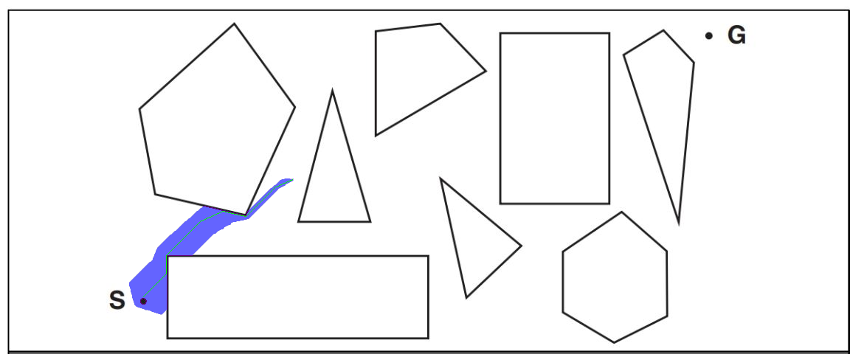

I know this is not a complete A star, but my computer is having trouble loading the whole image